*5th International Underground Excavations Symposium and Exhibition -UYAK2023*

*Istanbul, March 2023*

**5th INTERNATIONAL UNDERGROUND EXCAVATIONS SYMPOSIUM AND EXHIBITION – TITLE OF PAPER**

Write the name(s) of the author (e.g. A.Tamer Balkan, Ahmet Yazar) (write the e-mail address)

*Write the institutional information of the author (e.g. Hacettepe University, Mining Engineering Department, Ankara)*

Write the name(s) of the other author (e.g. Mehmet Aydın) (write the e-mail address)

*Write the institutional information of the author (e.g. MTA Feasibility Division, Ankara)*

Write the name(s) of the other author (e.g. Mehmet Durmaz) (write the e-mail address)

*Write the institutional information of the author (e.g. Yeni Vizyon Company., İstanbul)*

**ABSTRACT**

Expanded abstract, Expanded abstract. Expanded abstract. Abstract. Expanded abstract. Expanded abstract. Expanded abstract. Expanded abstract. Expanded abstract. Expanded abstract. Expanded abstract. Expanded abstract. Expanded abstract. Expanded abstract. Expanded abstract. Expanded abstract. Expanded abstract. Expanded abstract. Expanded abstract. Expanded abstract. Expanded abstract. Expanded abstract. Expanded abstract. Expanded abstract. Expanded abstract. Expanded abstract. Expanded abstract.

Expanded abstract, Expanded abstract. Expanded abstract. Abstract. Expanded abstract. Expanded abstract. Expanded abstract. Expanded abstract. Expanded abstract. Expanded abstract. Expanded abstract. Expanded abstract. Expanded abstract, Expanded abstract. Expanded abstract. Abstract. Expanded abstract. Expanded abstract.

Table 1. title for table 1

|  |  |  |  |  |
| --- | --- | --- | --- | --- |
| Year | A Parameter | B Parameter | C Parameter | D Parameter |
| 1960 | 1 | 2 | 3 | 4 |
| 1965 | 1 | 2 | 3 | 4 |
| 1970 | 1 | 2 | 3 | 4 |
| 1975 | 1 | 2 | 3 | 4 |

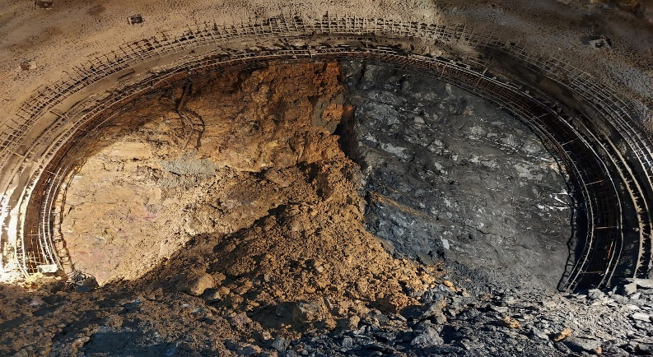

Figure 1. title for figure 1, centered.

Expanded abstract, Expanded abstract. Expanded abstract. Abstract. Expanded abstract. Expanded abstract. Expanded abstract. Expanded abstract. Expanded abstract. Expanded abstract. Expanded abstract. Expanded abstract. Expanded abstract, Expanded abstract. Expanded abstract. Abstract. Expanded abstract. Expanded abstract.